|  |  |  |  |  |  |  |
| --- | --- | --- | --- | --- | --- | --- |
| 適 用 產 品 | | | 站 別 | 編　　號 | EUTECTIC1610-OI01 | |
|  | | | 晶粒黏著共晶 | 制訂日期 | NOV.11.2023 | |
| 如範圍 | | | Eutectic DB | 頁　　數 | 全36頁第 1 頁 | |
|  | | | 1610 | 版　　次 | 第 03 版 | |
| 變更日期 | 版次 | 改　　　　訂　　　　內　　　　容 | | | | 修 訂 |
| NOV.11.2023 | 00 | 新增製程站點碼並拆分製程別，新增文件 | | | | 黃裕騰 |
| JUNE.04.2024 | 01 | 1. 新增7.14晶粒吸取方向規定  2. 新增7.16待生產晶片放置規定  (原本應為”修正”內容，但因應NCR24050056 特別使用”新增”for LG) | | | | 黃麗容 |
| Nov.30.2024 | 02 | 1. 新增SOT-523 HD、SOT-563 HD、SOD-323 HD、SOT-323 HD、SC-89  2. 修訂3名詞及定義& 4設備及治具  3. 修訂5.2各原物料號及料名，依照新的BOM表, 新增&移除現行BOM表中有的原物料  4. 修訂6.1中文及英文名詞&檢驗頻率&抽樣數述敘修正&記錄表單&判定標準→對應至項目  5. 6.2.2.2 修訂吸嘴印判定標準  6. 6.2.2.3修正尺寸晶粒表示及打線名稱英文  7. 修訂6.5 移除< JCM/ASM/SKW機台><生產中的機台必須每片做一次晶粒測高、頂針測高動作(小訊號SOD/SOT/DFN產品)>  8. 6.6整合彈匣使用規定  9. 修訂6.11移除<溫濕度超出規格時該時段生產材料需確認拉推力&球徑厚&弧高&晶推&外觀確認>  10. 6.12防潮氮氣櫃管制規定新增6.12.5  11. 6.15&6.16 塑膠袋封裝→包裝袋密裝  12. 修訂6.20.1 移除<Central代工產品作業前需進行上述確認>  13. 修訂6.20.2更新流程圖片  14. 修訂6.20.3 移除<針對三菱產品更換之頂針須確認頂針外觀>  15. 修訂6.21晶片chipping檢查→藍膜及晶粒外觀標準並追加6.21.1  16. 修訂6.23移除<或DFN良率<50%未滿條>  17. 修訂6.24 移除Die Saw及表格內容優化  18. 原6.25<ASM機台PR辨識模式設定 ASM PR mode setting>移除  19. 修訂6.25移除<安波福產品在>一文  20. 新增6.27&6.28&6.29  21. 刪除原7.2參數變更時,機台參數變更記錄表上每個欄位應確實填寫  22. 原7.3由更改人(工程師/班長)及負責之作業員各點檢填寫一次並簽名更正成7.2參數變更後,參數檢查記錄表上應立即由更改人填寫參數並簽名  23. 刪除原7.4&7.5移除  24. 原7.12JCM/TOSOK/ASM更改成7.9 JCM/TOSOK/ASM/STC  25. 原7.14晶粒吸取方向由晶片上方往下方吃，機台設定請選Left Down或Right Down更正成7.11除破片/非圓形且具方向性(MOS/TRA)之晶片外，晶粒吸取方向必須由晶片上至下  26. 原7.15.1&7.15.2內文修正合併→7.12更換吸嘴後須執行晶片測高及腳架測高  27. 9.1.3修正成<若改作業AUTOMOTIVE產品則須選擇AU機台>  28. 9.1.4修正成<叫程式, 若無程式則待PE or EE>  29. 9.2.1操作流程改用SOP呈現  30. 新增9.2.2參數調整流程圖表  31. NCR開單標準 For AU由原> 1%或連續兩批>0.5%>1% or accumulate 2 lots > 0.5%更改成>0.8% | | | | 許閔捷 |
| Feb.10.2025 | 03 | 1. 移除6.25 Void檢驗片需報廢規定 2. 7.11晶片作業方向規定變更 | | | | 劉念萱 |

1. 目的　Purpose

將晶粒與腳架焊接作為後段作業基準。

To attach the die from the wafer to the leadframe die attach pad (DAP)

1. 範圍　Scope

SOD-123 / 323 / 523 / 923 / SOT-23 / 323 / 353 / 363 / 523/543 / 553 / 563/ SOD-323HE(18mil以下) /SOT-523 HD、SOT-563 HD、SOD-323 HD、SOT-323 HD、SC-89

1. 名詞及定義　Terms and Definitions
   1. Die：晶粒
   2. Die Bond：晶粒黏著
   3. LeadFrame：腳架
   4. Collet：吸嘴
   5. Wafer：晶片
   6. Magazine：彈匣
   7. Ejector pin：頂針
   8. Bonding Diagram：打線圖
   9. PBI(Post Bond Inspection)：銲接後偵測
   10. PR：圖像辨識
   11. Clamp：壓弓
   12. Plate：底板
   13. Traveler card：工單
2. 設備及治具　Equipment and tools
   1. TOSOK DBD4000、DBD4200R、DBD4000、EBD4350、EBD4000S、DBD3310、 DBD4000、DBD4200R、ASM AD832UR、SHINKAWA STC-800 DIE BONDING機台及附屬設備  
      TOSOK DBD4000、DBD4200R、DBD4000、EBD4350、EBD4000S、DBD3310、 DBD4000、DBD4200R、ASM AD832UR、SHINKAWA STC-800 DIE BONDING Machines and accessories equipment.
   2. TOSOK CM2200E LEAD FRAME CUTTING機台或類似設備

TOSOK CM2200E LEAD FRAME CUTTING Machine or similar equipment

* 1. 鑷子。Tweezers.
  2. 彈匣。Magazine.
  3. 吸嘴。Collet.
  4. 頂針。Ejector pin.
  5. 底板。Plate

1. 原物料　Materials
   1. 切割完晶片 Sawn or diced wafers.
   2. 各原物料號及料名 Part number and description

|  |  |
| --- | --- |
| 料　　號 Part No | 料　　　　名 Description |
| LEF000013 | 腳架/SOD-123/BASE/REEL/A42 |
| LEF000016 | 腳架/SOD-323/OPTION 1/REEL/A42 |
| LEF000121 | 腳架/SOD-123/BASE(V溝)/REEL/A42 |
| LEF000019 | 腳架/SOD-523/OPTION 1/REEL/A42 |
| LEF000022 | 腳架/SOD-923/BASE/REEL/A42 |
| LEF000027 | 腳架/SOT-23/OPTION 2/REEL/A42 |
| LEF000024 | 腳架/SOT-23/OPTION 5/REEL/Cu |
| LEF000026 | 腳架/SOT-23/OPTION 1/REEL/A42 |
| LEF000044 | 腳架/SOT-363/OPTION 3/REEL/A42 |
| LEF000148 | 腳架/SOT-363/OPTION 3/REEL/A42 |
| LEF000101 | 腳架/SOT-363/OPTION 9/REEL/Cu |
| LEF000129 | 腳架/SOT-363/OPTION 1(V溝)/REEL/A42 |
| LEF000048 | 腳架/SOT-523/OPTION 1/REEL/A42 |
| LEF000149 | 腳架/SOT-523HD/OPTION 1/REEL/Cu// |
| LEF000039 | 腳架/SOT-323/OPTION 1/REEL/A42 |
| LEF000125 | 腳架/SOT-323/OPTION 1(V溝)/REEL/A42 |
| LEF000025 | 腳架/SOT-23/OPTION 6/REEL/Cu |
| LEF000028 | 腳架/SOT-23/OPTION 3/REEL/A42 |
| LEF000041 | 腳架/SOT-323/OPTION 3/REEL/A42 |
| LEF000023 | 腳架/SOT-23/OPTION 4/REEL/Cu |
| LEF000065 | 腳架/SOT-563/OPTION 6/REEL/A42 |
| LEF000151 | 腳架/SOT-563/HD/OPTION 6/REEL/Cu |
| LEF000042 | 腳架/SOT-363/OPTION 1/REEL/A42 |
| LEF000146 | 腳架/SOT-363/OPTION 1/REEL/A42 |
| LEF000102 | 腳架/SOT-363/OPTION 7/REEL/Cu |
| LEF000051 | 腳架/SOT-563/OPTION 1/REEL/A42 |
| LEF000043 | 腳架/SOT-363/OPTION 2/REEL/A42 |
| LEF000147 | 腳架/SOT-363/OPTION 2/REEL/A42 |
| LEF000100 | 腳架/SOT-363/OPTION 8/REEL/Cu |
| LEF000040 | 腳架/SOT-323/OPTION 2/REEL/A42 |
| LEF000050 | 腳架/SOT-523/OPTION 3/REEL/A42 |
| LEF000127 | 腳架/SOT-323/OPTION 3(V溝)/REEL/A42 |
| LEF000124 | 腳架/SOT-23/OPTION 3(V溝)/REEL/A42 |
| LEF000123 | 腳架/SOT-23/OPTION 2(V溝)/REEL/A42 |
| LEF000049 | 腳架/SOT-523/OPTION 2/REEL/A42 |
| LEF000087 | 腳架/SOT-523/OPTION 4/REEL/A42 |
| LEF000052 | 腳架/SOT-563/OPTION 2/REEL/A42 |
| LEF000122 | 腳架/SOT-23/OPTION 1(V溝)/REEL/A42 |
| LEF000045 | 腳架/SOT-363/OPTION 4/REEL/A42 |
| LEF000067 | 腳架/SOT-563/OPTION 8/REEL/A42 |
| LEF000053 | 腳架/SOT-563/OPTION 3/REEL/A42 |
| LEF000066 | 腳架/SOT-563/OPTION 7/REEL/A42 |
| LEF000074 | 腳架/SOD-323HE/BASE/REEL/Cu |
| LEF000156 | 腳架/SOT-323/HD/Option A/REEL/Cu// |
| LEF000157 | 腳架/SOT-323/HD/Option B/REEL/Cu// |
| LEF000154 | 腳架/SOD-323/HD/Option A/REEL/Cu// |
| LEF000017 | 腳架/SOD-323/OPTION 2/REEL/A42 |
| LEF000155 | 腳架/SOD-323/HD/Option B/REEL/Cu// |
| LEF000054 | 腳架/SOT-563/OPTION 4/REEL/A42 |
| LEF000047 | 腳架/SOT-363/OPTION 6/REEL/A42 |
| LEF000105 | 腳架/SOT-363/OPTION 12/REEL/Cu |
| LEF000136 | 腳架/SOT-23/OPTION 4(V溝)/REEL/Cu |
| LEF000046 | 腳架/SOT-363/OPTION 5/REEL/A42 |
| LEF000055 | 腳架/SOT-563/OPTION 5/REEL/A42 |
| LEF000158 | 腳架/SC-89/OPTION 1/REEL/Cu |

1. 管制與規格　Control and Specificaiton
   1. DB製程品質管制 DB control and setting

|  |  |  |  |  |  |
| --- | --- | --- | --- | --- | --- |
|  | 1.確認晶粒推力  Check die shear | | 2.核對貼晶位置及方向  Verify bonding position and direction | | 3.核對參數設定  Verify parameter condition |
| 檢驗人員  Checker | PD | IPQC | PD | | |
| 檢驗工具  Measurement tool | 推拉力機  Pull and shear tester | | 目視檢查  Visual Inspection | | |
| 檢驗頻率  Check frequency | 1. 維修Maintenance 2. 換頂針   Change Ejector pin   1. 換Type   Change Type   1. 開機 Machine power on   5. 復機(12hr) Restart | 1. 每天 Everyday 2. 換Package Change package | 換Type  Change Type | 1.每班  Every Shift  2.換Type  Change type  3.維修  Maintenance | |
| 抽樣數  Sample size | 腳架一行的數量  The quantity of one column of L/F | | 一次  Once | | |
| 記錄表單  Check list | 品質管制圖  Control chart  X-R CHART F-QC1035 | | 檢查記錄表  Record sheet  F-RD09M4 | 檢查記錄表  Record sheet  F-RD09L8/ F-PE09H6/F-PE09C7/ F-PE09J9 | |
| 判定標準  Check criterion | 依照6.2  Follow 6.2 | | 依照打線圖  Follow bonding diagram | 依照6.3  Follow 6.3 | |

|  |  |  |  |
| --- | --- | --- | --- |
|  | 4. 焊接外觀  Check bonding appearance | | |
| 檢驗人員  Checker | PD | | IPQC |
| 檢驗工具  Measurement tool | 顯微鏡(30x 以上)  Microscope(30x up) | | |
| 檢驗頻率  Check frequency | 1.每班  Every shift  2.維修  Maintenance  3.參數變更  Change parameter  4.換Type  Change type  5.開機  Machine power on | 1.換吸嘴  Replace Collet  2.每兩小時  Every two hours | 1.每班  Every shift  2.換Package  Change package |
| 抽樣數  Sample size | 一條(SOD/SOT)  1 strip (for SOD/SOT) | | |
| 記錄表單  Check list | 檢查記錄表  Record sheet F-RD09M4 | 檢查記錄表  Record sheet F-PE09D0 | 品質管制圖  Control chart  SPC system |
| 判定標準  Check criterion | 依照6.4  Follow 6.4 | | |

|  |  |  |  |
| --- | --- | --- | --- |
|  | 5. 確認焊接氣孔  Check Void | 6. 確認吸嘴壽命&規格  Check collet life & specifications | 7. 確認頂針壽命&規格  Check ejector pin Llfe & specifications |
| 檢驗人員  Checker | IPQC | PD | EE |
| 檢驗工具  Measurement tool | X-Ray | 裝著機計數器  Die Bonding machine Counter | |
| 檢驗頻率  Check frequency | 1. 換Type  Change Type  2. 每班  Every shift  3. 開機  Machine power on  4.參數變更  Change parameter  5. 維修或更換頂針  Mainteance or Change ejector pin | 每次  Every time | 每次  Every time |
| 抽樣數  Sample size | 一條腳架，並記錄最大的五顆Inspect the entire lead frame and record the five largest value. | 1次  Once | |
| 記錄表單  Check list | SPC system | 更換記錄表  Record sheet  F-PE0945 | MES system |
| 判定標準  Check criterion | Eutectic(晶粒背面金屬錫):Total≦40%晶粒面積Eutectic(Die back side metal SN):Total≦40% of the die area.  Eutectic(晶粒背面金屬金):Total≦50%晶粒面積Eutectic(Die back side metal AU):Total≦50% of the die area. | 依照6.3  Follow 6.3 | 依照6.3  Follow 6.3 |

|  |  |  |
| --- | --- | --- |
|  | 1. 8. 離子風扇點檢 Ion fan check | 9. 貼晶偵測  Inspection die position |
| 檢驗人員  Checker | PD | N/A |
| 檢驗工具  Measurement tool | 目視檢查  Visual Inspection | PBI |
| 檢驗頻率  Check frequency | 每天  Every Day | N/A |
| 抽樣數  Sample size | 1次  Once | 每顆  Every unit |
| 記錄表單  Check list | 檢查記錄表  Check List　F-PE09C0 | N/A |
| 判定標準  Check criterion | 正常做動  Operated | X/Y shift < 50um  Rotation < 5° |

* 1. 晶粒推力測試判定規格 Die shear test check criterion :

|  |  |
| --- | --- |
| 管　　制　　特　　性  Control characteristic | 管　制　規　格  Control Spec. |
| 晶粒面積　Die area：69mil 2 | 55 g ↑ |
| 晶粒面積　Die area：81mil 2 | 65 g ↑ |
| 晶粒面積　Die area：100mil 2 | 80 g ↑ |
| 晶粒面積　Die area：121mil 2 | 97 g ↑ |
| 晶粒面積　Die area：144mil 2 | 115 g ↑ |
| 晶粒面積　Die area：169mil 2 | 135 g ↑ |
| 晶粒面積　Die area：196mil 2 | 157 g ↑ |
| 晶粒面積　Die area：225mil 2 | 180 g ↑ |
| 晶粒面積　Die area：256mil 2 | 205 g ↑ |
| 晶粒面積　Die area：289mil 2 | 231 g ↑ |
| 晶粒面積　Die area：324mil 2 | 259 g ↑ |
| 晶粒面積　Die area：361mil 2 | 289 g ↑ |
| 晶粒面積　Die area：400mil 2 | 320 g ↑ |
| 晶粒面積　Die area：441mil 2 | 353 g ↑ |
| 晶粒面積　Die area：484mil 2 | 387 g ↑ |
| 晶粒面積　Die area：529mil 2 | 423 g ↑ |
| 晶粒面積　Die area：576mil 2 | 461 g ↑ |
| 晶粒面積　Die area：625mil 2 | 500 g ↑ |
| 晶粒面積　Die area：676mil 2 | 541 g ↑ |
| 晶粒面積　Die area：729mil 2 | 583 g ↑ |
| 晶粒面積　Die area：784mil 2 | 627 g ↑ |
| 晶粒面積　Die area：841mil 2 | 673 g ↑ |
| 晶粒面積　Die area：900mil 2 | 720 g ↑ |
| 晶粒面積　Die area：961mil 2 | 769 g ↑ |
| 晶粒面積　Die area：1024mil 2 | 819 g ↑ |
| 晶粒面積　Die area：1089mil 2 | 871 g ↑ |
| 晶粒面積　Die area：1156mil 2 | 925 g ↑ |
| 晶粒面積　Die area：1225mil 2 | 980 g ↑ |
| 晶粒面積　Die area：1296mil 2 | 1037 g ↑ |
| 晶粒面積　Die area：1369mil 2 | 1095 g ↑ |
| 晶粒面積　Die area：1444mil 2 | 1155 g ↑ |
| 晶粒面積　Die area：1521mil 2 | 1217 g ↑ |
| 晶粒面積　Die area：1600mil 2 | 1280 g ↑ |
| 晶粒面積　Die area：1681mil 2 | 1345 g ↑ |
| 晶粒面積　Die area：1764mil 2 | 1411 g ↑ |
| 晶粒面積　Die area：1849mil 2 | 1479 g ↑ |
| 晶粒面積　Die area：1936mil 2 | 1549 g ↑ |
| 晶粒面積　Die area：2025mil 2 | 1620 g ↑ |
| 晶粒面積　Die area：2116mil 2 | 1693 g ↑ |
| 晶粒面積　Die area：2209mil 2 | 1767 g ↑ |
| 晶粒面積　Die area：2304mil 2 | 1843 g ↑ |
| 晶粒面積　Die area：2401mil 2 | 1921 g ↑ |
| 晶粒面積　Die area：2500 mil 2 | 2000 g ↑ |
| ※晶粒面積不是上述所示者，推力規格以上述所示大於實際晶粒面積之條件為規格  The die area is not shown in the above-mentioned, the specification of die shear is for largest die area.  e.g. 實際晶粒面積為1200mil 2其推力規格以晶粒面積1225mil2為規格  e.g. The actual die area of 1200mil, its to the specification of die shear is for standard 1225mil | |

6.2.1 參數規格 Parameter specification：

6.2.1.1 JCM/TOSOK：參照DB-PA003 JCMTOSOK參數表Follow DB-PA003

6.2.1.2 ASM：參照DB-PA004 ASM AD832UR參數表 Follow DB-PA004

* + - 1. Shinkawa：參照DB-PA002 Shinkawa參數表 Follow DB-PA002

6.2.2 焊接外觀判定標準 Bonding appearance check criterion：

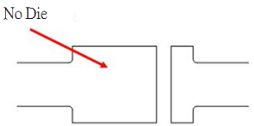 6.2.2.1 空晶 No die : 腳架上無晶粒No die on the L/F.  
判定規格 Check specification : 貼晶不完全及無晶粒 No die or die bonder

6.2.2.2 吸嘴印判定標準Collet mark standard

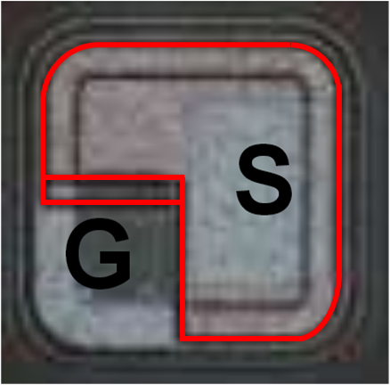MOS：壓傷gate/dource迴路拒收。Reject if gate/source circult is damaged.

吸嘴印不得壓到紅框 Collet mark is not allowed if touch the red rectangle.

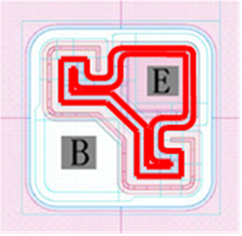TRA：壓傷base/emitter迴路拒收。Reject if base/emitter circult is damaged.

吸嘴印不得壓到紅框 Collet mark is not allowed if touch the red rectangle.

Others： 超出氧化層拒收。 Reject if over the oxidized area.

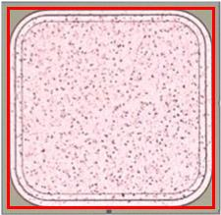吸嘴印不得超出紅框 Collet mark is not allowed if over the red rectangle.

6.2.2.3 貼晶位置 Bond Position:  
晶粒位置及共晶製程金水不得超出腳架鍍銀區域並符合以下圖示規範 ，除非打線圖另有規定 Bond position and wetting of eutectic isn’t allowed over edge of bond pad and follow the following diagram, otherwise ruled in BD..

| Package | 晶粒尺寸  Die size | 打線方式  WB form | 貼晶位置  Bonding position | 備註  Note |
| --- | --- | --- | --- | --- |
| SOT-23 | ≧25 mil | 單晶雙線/雙胞胎晶粒  1D2W/ Twin die |  | 晶粒貼於 PAD 正中央  Bonding in the pad center |
| SOT-23 | <25 mil | 單晶單線  1D1W |  |  |
| SOT-23 | All | 雙晶雙線  2D2W |  |  |
| SOD-323 | All | 單晶單線  1D1W |  |  |
| SOD-123 | <25 mil | 單晶單線  1D1W |  |  |
| SOD-123 | ≧25 mil | 單晶雙線  1D2W |  | 晶粒貼於 PAD 正中央  Bonding in the pad center |
| SOT-323 | All | 單晶雙線/雙胞胎晶粒  1D2W/ Twin die |  | 晶粒貼於 PAD 正中央  Bonding in the pad center |
| SOT-323 | All | 單晶單線  1D1W |  |  |
| SOT-363 | － | 四晶四線  4D4W |  |  |
| SOT-363 | － | PJSRV05W-  4LC |  | 針對單晶粒部份以腳架中心為參考點，左右不超過晶粒一半，如 11mil 晶粒不超過0.14mm 為範圍， BAV70 兩顆晶粒設定範圍： 0.44mm<X1-X2< 0.57mm  The distance between l.f right and l.f. left must less than half of die size when the reference point at the center of l.f.. |
| SOD-523 | All | BOSB |  | 大晶粒貼於大 PAD 正中央A點：大 Pad 邊緣到小晶粒邊緣之規格允許 90～150um  Larger die bonding in position A and the distance between edge of the large pad and smaller die is allowed 90~150um. |
| SOD-523 | All | 單晶單線  1D1W |  | 晶粒貼於 PAD 正中央  Bonding in the pad center |
| SOD-923 | All | BSOB |  | 晶粒距離上方0.05-0.1mm  X方向貼於中間  0.05-0.1mm from top edage of pad, and in center of x direction |
| SOT-523 | All | 單晶雙線  1D2W |  | 貼晶位置依圖示規定  Bonding position must follow the specification shown in graph |

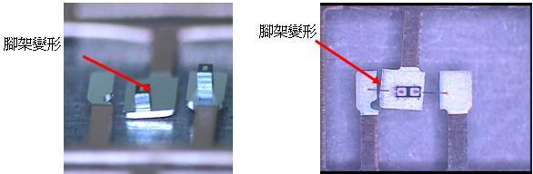6.2.2.4 腳架變形判定標準 L/F deform standard : 腳架水平與符合打線圖示L/F level and refer to the Bonding Diagram.

6.2.2.5 打線區噴錫檢查 2nd bond pollution check：DB作業完成需檢查二銲點位置是否被噴出錫水沾附 Check there is no pollution on 2nd bond

6.3 腳架使用規定 Requirements for Use of Lead Frames: 依照打線圖及工單標註之規定。Leadframe option to be used is in accordance with the bonding diagram document xxxxxxx-BDxxx & traveler card.

6.4 吸嘴使用判定標準。Collet appearance standard.

|  |  |  |
| --- | --- | --- |
| 吸嘴照片  Collet picture | 11 | 12 |
| 吸嘴使用情況  Usage | 吸嘴正常可使用  OK | 吸嘴損壞需更換  NG |

※異常時更換之吸嘴 &未達使用壽命；換下之吸嘴 &到達使用壽命取下之吸嘴，一律報廢處置。The collet that is replaced when it is abnormal,replaced beforce it’s service life and removed when it reaches it’s service life,shall be discarded and disposed .

* 1. 每2小時需使用無纖棉棒清潔吸嘴。Clean collet with a fiberless swab every 2 hours.



* 1. 彈匣MAGAZINE使用規定　The use rules for magazine.
     1. 彈匣對應腳架規定

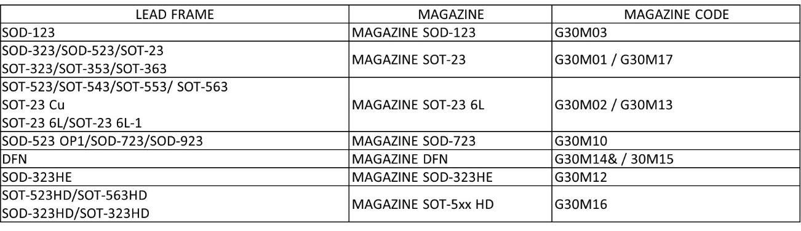

* + 1. 彈匣使用類型規定 Requirements for the type of magazine to be used
       1. 彈匣類型 Types of magazine

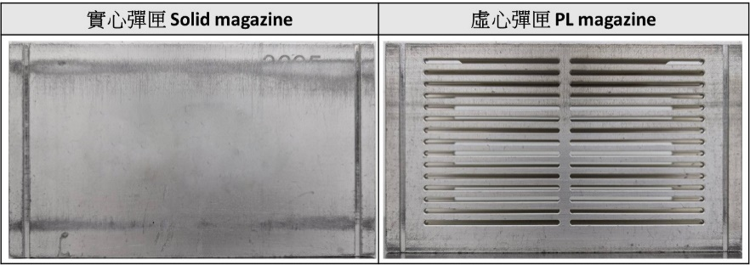

* + - 1. 彈匣類型對應 Mapping of magazine types.

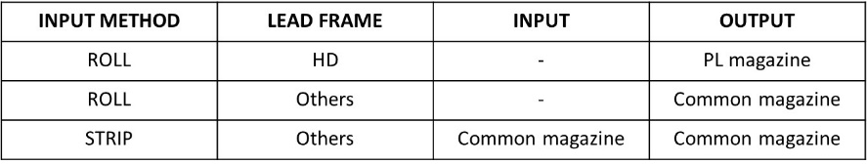

* 1. 銅腳架必須於DBD-4200R(須有六個加熱區)或者STC-800/AD832UR之機台生The copper lead frame must be produced on a DBD-4200R (with six heating zones) or STC-800/AD832UR machine.
  2. D / B生產過程中，若發現有接駁處塗黑處理的腳架，請將塗黑處的腳架報廢，不可做成型試模材料，以免模具受損。The welded leadframe marked in dark color must be scrip during die bonding in order to avoid damaging the mold tool during molding process.

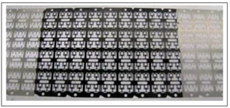

* 1. 切片完的腳架之處置方式How to keep lead frame

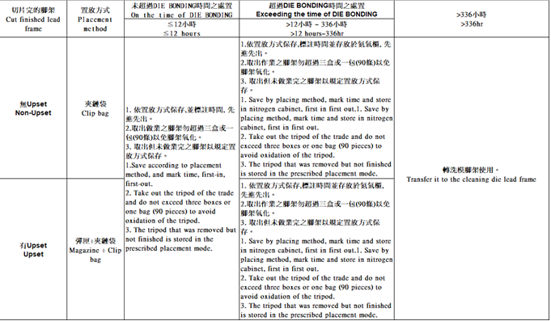

* 1. 腳架外觀規範依照各圖面規格為準。Leadframe dimension specification must follow the material drawing.
  2. 溫濕度管控 Temperature and humidity control:
     1. 溫濕度每班記錄一次，溫度規格：18~26℃，濕度規格：35~60%。並記錄於F-RD09F1。Temperature spec.：18~26℃, Humidity spec.：35~60%, Recording will be done on per shift basis and recording in F-RD09F1. 溫度小於19℃或大於25℃及濕度小於40%或大於55%時需通知廠務處理。 Die shear and appearance must be check for every lot and inform Facility Eng. Team if temperature is lower than 19℃; higher than 25℃ or humidity is lower than 40%; higher than 55%.
  3. 防潮氮氣櫃管制規定 Control Requirements for Moisture-proof Nitrogen Cabinets:
     1. 濕度：30±15%，氮氣流量：20±3 L/mim，若濕度>30%需充填氮氣; <30%停止供應氮氣。 Humidity：30±15%; N2 flow：20±3 L/mim; if humidity>30%, the N2 must be purged or humidity<30%, the N2 must be stop purged.
     2. 無濕度控制調整之機台無須做濕度管制。Humidity control is not required for machines without humidity control adjustment.
     3. 無氮氣流量控制調整之機台則無須做流量管制。Flow control is not required for machines without nitrogen flow control adjustment.
     4. 防潮氮氣櫃應由幹部或指定人員於每班上班後點檢，並記錄於表單(F-PE0931)，若有不符規定時必須通知設備人員確認與處理。Moisture-proof nitrogen cabinets should be inspected at the beginning of each shift by an shift leader or a designated person and recorded in the sheet (F-PE0931), and if there is any non-compliance with the requirements, EE must be notified to confirm and deal with the situation.
     5. 溫度規格：18~26℃，溫度小於19℃或大於25℃時需通知廠務。Temperature spec.：18~26℃. If the temperature is less than 19 ℃ or greater than 25 ℃, the factory service should be notified.
  4. SOD-323HE晶粒與製程搭配　Die size and process setting for SOD-323HE package

|  |  |
| --- | --- |
| 晶粒尺寸 Die Size≦20mil | 共晶製程 (Eutectic) |
| 晶粒尺寸 Die Size≧21mil | 網印製程 (Screen Print) |

* 1. 裝進彈匣內之半成品，僅在抽測外觀及推力時才可抽出作業。The products must not be removed from the magazine except for a appearance and die shear inspection.
  2. 腳架從進廠、檢驗至生產線上，除架在機台上生產外，一律用包裝袋密裝。Leadframe must be packed in plastic bag during incoming inspection, or in the production line temporary storage area, except that the machine is running production.
  3. 架在機台上的腳架若超過24小時以上不生產，一律卸下用包裝袋密裝。The leadframe installed on the machine that is not running must not exceed 24 hours. More than 24 hrs exposed leadframe must be packed with the plastic bag.
  4. 防靜電處理　Electrostatic protection
     1. 操作人員進入無塵室一律著抗靜電衣、抗靜電帽、抗靜電鞋。Production personel must wear electrostatic protective dress, ap and shoes in the production area.
     2. 操作人員於操作機台時，應配帶防靜電手套及靜電環，且將靜電環夾具連接至機台上，不操作時將夾具或靜電環取下。The operator must put on electrostatic protective gloves and ring when working.
     3. 機台上若有加裝離子風扇或抗靜電器具，作業時請務必使用。The operator must turn on the accessories as ion fan or others electrostatic protector .
     4. 有配置靜電風扇/離子槍之機台需每日確認裝置是否作動，若無須通知EE維修。The die bonder with ion fan or ion gun must be check that the device is working, if the device is stop running must inform EE to maintence.
     5. 其餘規定依照ESD靜電防護管制規範(W-PE0916)之規定。Other rules follow ESD Electrostatic protection Standard(W-PE0916)..
  5. 代工產品OEM products
     1. 只要有報廢不良品(不論多寡)，皆須隨當批材料至TMTT站。Scrap materials have to go to the station TMTT
     2. 不良率>=2%以上才開單立品質異常單通知製程或相關單位分析。When the defect rate >=2%, MF department have to write down Quality exception notice and sent to PE department or relate department.
     3. 特殊客戶要求不在此限 。Special customer requirements are not restricted.
  6. 晶粒吸取範圍作業規定 pickup range specified
     1. JCM/TOSOK：參照DB-PA003 JCMTOSOK參數表revised to DB-PA003
     2. ASM：參照DB-PA004 ASM AD832UR參數表 revise to DB-PA004
     3. Shinkawa：參照DB-PA002 Shinkawa參數表 revise to DB-PA002
  7. 頂針更換 Replacement of Ejector pin
     1. 頂針痕外觀標準 Ejector pin mark standard  
        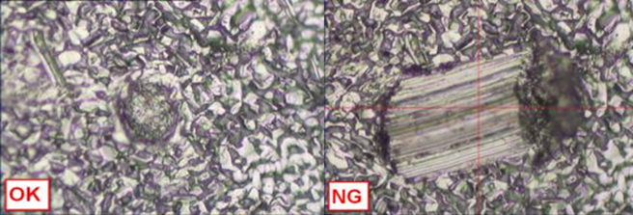

更換頂針後由設備人員操作機台拿取晶粒並於高倍顯微鏡上確認頂針針痕。確認結果由設備人員紀錄於MES系統，針痕照片由設備人員保存。Check the backside of chip wich is shown as graph, which is done by PD and EE. The result must be recorded in MES system and the phoro must be saved by EE.

* + 1. 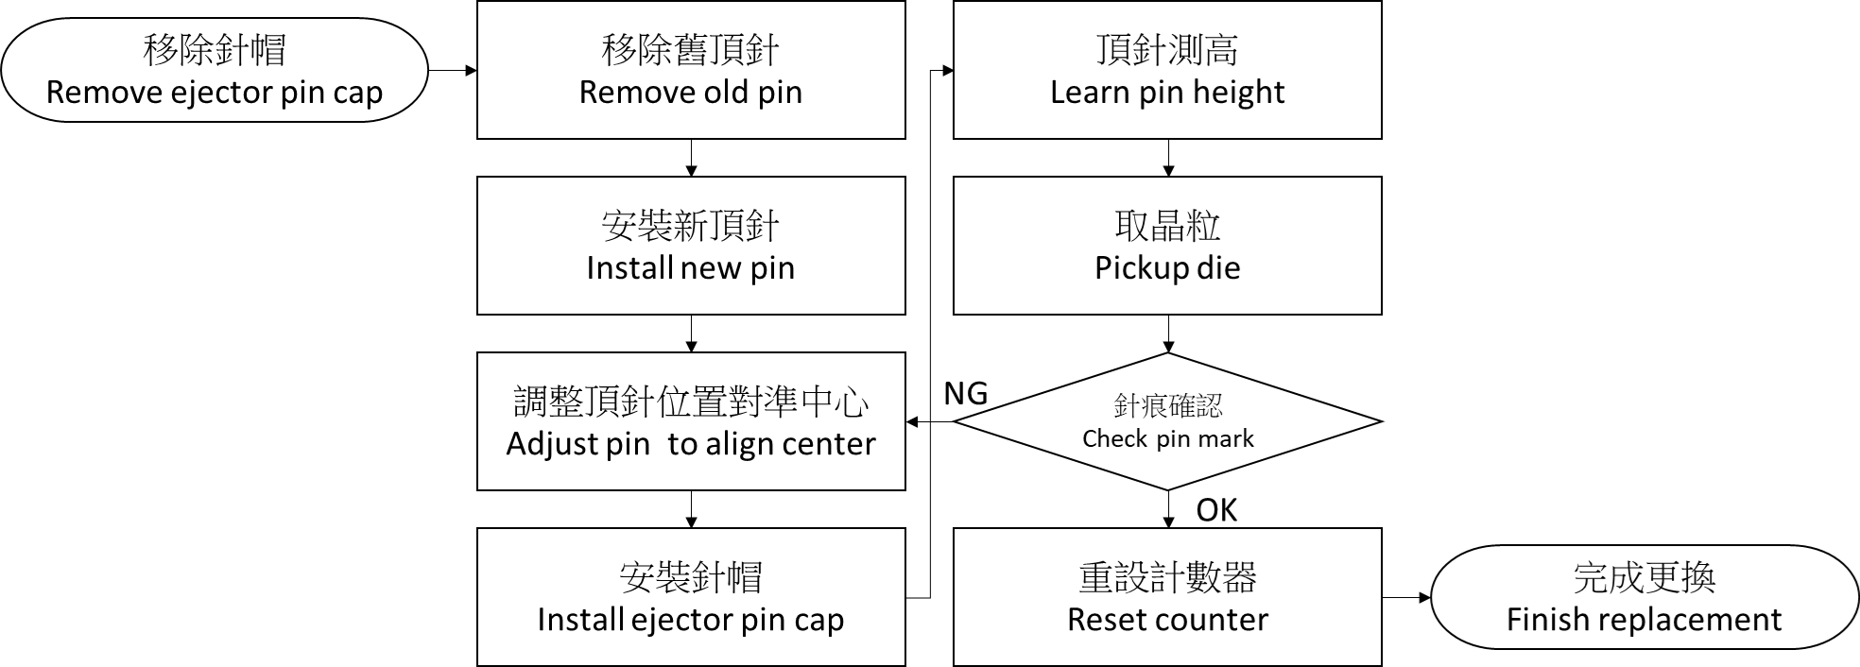更換流程 Replacement flow
    2. 頂針外觀標準Ejector pin appearance standard  
       若頂針外觀如下圖NG所示, 即使尚未達使用壽命仍需進行更換. If the appearance of the ejector pin is as shown in Figure NG below, it should be replaced even if it has not yet reached the end of its usage limit.

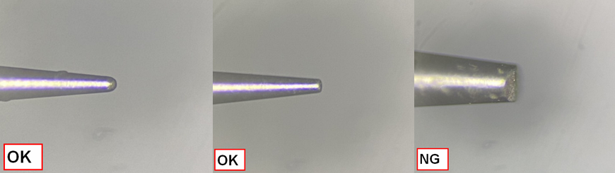

* 1. 藍膜及晶粒外觀標準 Blue tape and die appearance standard
     1. 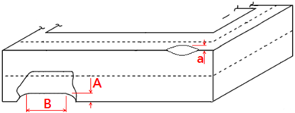正/背崩 Top side/ back side chipping:   
        作業中之晶片每片需確認是否有chipping, 規格如下所示。Chipping must be checked for each wafer, the specification as follows.

|  |  |  |
| --- | --- | --- |
| 種類  Category | 正面  chipping (a) | 背面  chipping(A) |
| 一般品  Noemal | 不得超出氧化層或保護層  Inner the oxided layer or guarding layer | <45um |
| 車用品  Automotive | Die Size≤9mil, <20um |
| 9.1mil< Die Size ≤11mil, <22um |
| 11.1mil< Die Size ≤14mil, <25um |
| 14.1mil< Die Size ≤17mil, <34um |
| 17.1mil< Die Size ≤20mil, <41um |
| 20.1mil< Die Size, <45um |

* 1. 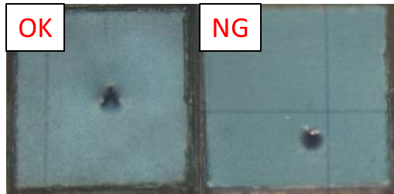頂針位置標準 Ejector pin position standard  
     頂針需位於晶粒中心如下所示 The ejector pin position must under the center of die.
  2. DB後良率<80%需報廢。The products must be rejected if yield<80% after DB process
  3. Q-TIME管控項目及動作 Q-TIME control

|  |  |  |  |  |  |
| --- | --- | --- | --- | --- | --- |
| Timer Name | 啟動時機  Start Timing | | 停止時機  Stop Timing | | 管控時間  Q-TIME |
| D/B Start to D/B Out | D/B-START | Move In | Eutectic D/B | Track Out | ≦120hrs |
| Eutectic D/B to W/B In | Eutectic D/B | Track Out | W/B | Track In | ≦48hrs |

* 1. ~~氣孔檢驗完成之腳架須報廢。The leadframe used in void check must be scraped~~
  2. 共晶AU產品於新川作業需使用post bond inspection規格設定為x/y偏移上限±100um，角度偏移上限5°。 Post bond inspection must be used for AU grade products in eutectic process on shinkawa equipment. Specification setting for x/y shift upper limit ±100um, angular shift upper limit 5°.
  3. 若機台有post bond inspection功能，需開啟此功能。If the machine has post bond inspection function, this function should be enabled.
  4. 若機台有Leadfram orientation function，需開啟此功能。If the machine has Leadfram orientation function, this function should be enabled.
  5. 焊接氣孔檢驗方式Void inspection method :  
     SOD/SOT:檢驗一條腳架，並記錄最大的五顆。SOD/SOT: Inspect the entire lead frame and record the five largest value.

1. 注意事項　Notice
   1. 更換晶片時，須重新確認晶粒PR。Re check die PR when change wafer.record sheet should be completed and the reason noted in the comments column.
   2. 參數變更後，參數檢查記錄表上應立即由更改人填寫參數並簽名。After the parameter is changed, the parameter check record should be filled in and signed by the person who changed the parameter.
   3. 調機需使用dummy腳架，調機使用腳架需報廢處理。The dummy leadframe which is used in equipment adjustment must be scrapped.
   4. SOD-523之切片位置頭須特別注意，頭切在契形缺口的大圓洞與小圓洞之區域，正確位置如下：For the strip cutting position of SOD-523,it is between big hole and small hole and showed below

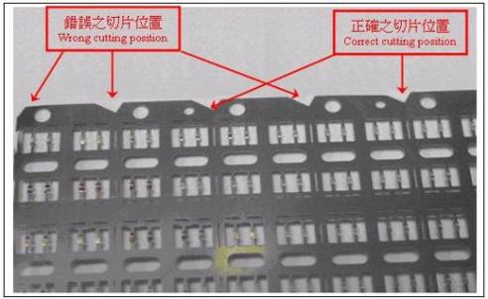

* 1. SOT-363切片位置頭須特別注意，頭切在契形缺口處，正確位置如下：For the strip cutting position of SOT-363,it is located on triangle cutted section and showed below

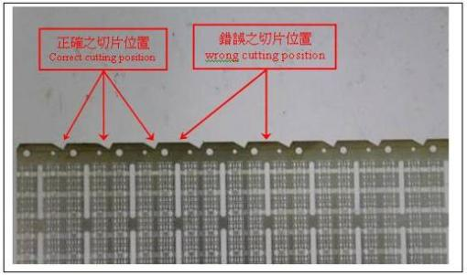

* 1. SOD-523 OP1、SOD-923腳架之辨識如下：The identification of leadframe for SOD-523 OP1, SOD-923 is showed below

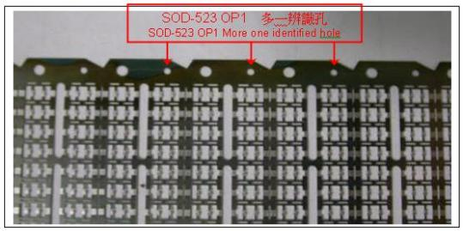



* 1. 在作業之前務必先確認吸嘴、頂針與CAMERA上十字線中心點位置是否在同一點上。Make sure that pick up tool, ejector pin pin must be aligned with respect to the cross hair before bonding.
  2. 機台參數變更記錄表,產線由每月歸檔更改為每年7月1日及1月2日歸檔，一年歸檔2次;未歸檔時應放置機台旁便於查詢或稽核。Machine parameters change log table, the production line by the monthly archive change annually on July 1 and January 2, archive 2 times a year; Unfiled should be placed next to the machine easy to check or audit.
  3. 更換吸嘴時須使用扭力扳手。JCM/TOSOK/ASM/STC使用0.2N-m搭配M3螺絲；Shinkawa使用0.08N-m搭配M2螺絲。Change JCM/TOSOK/ASM/STC D/B collet tool must use 0.2N-m torque wrench with M3 setscrew; Shinkawa with 0.08N-m and M2 setscrew.
  4. 晶片背金外觀   
     
  5. 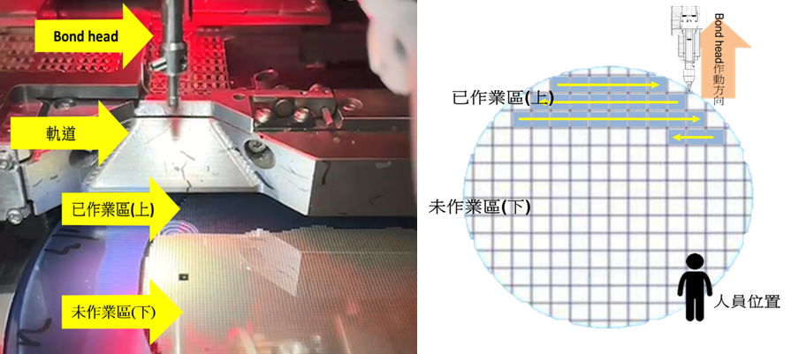除破片/非圓形或於JCM/TOSOK機台作業~~且具方向性(MOS/TR~~A)之晶片外，晶粒吸取方向必須由晶片上至下。Except for broken/uncircular or production by JCM/TOSOK ~~directional (MOS/TRA)~~ wafers, the direction of die pickup must be from the top to the bottom of the wafer.
  6. Bond head測高 Teach Bond height

更換吸嘴後須執行晶片測高及腳架測高。

After change collet, must relearn to wafer and lead-frame bond heigh.

* 1. 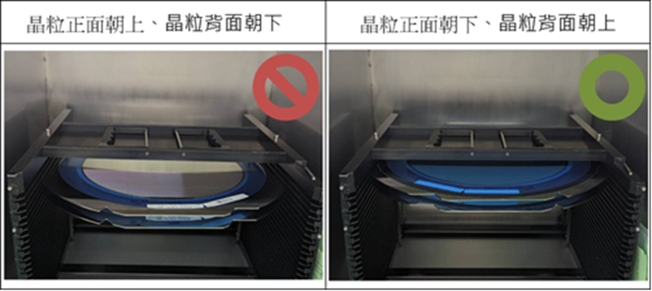待生產的晶片放入cassette時，晶粒正面須朝下，晶粒背面須朝上。When the wafer waiting to be produced is placed in the cassette, the top side of the die must be facing down and the back side of the die must be facing up.

1. 作業準備　Preparation
   1. 腳架穿過機台，此時須將CLAMP(腳架壓片)上升，再用鑷子一段一段的推入並穿過機台，腳架穿過機台後調整位置，使腳架在螢幕中之適當位置。Let leadframe feed through the machine, lift up the CLAMP(for leadframe clamper),then get leadframe through the machine one section by one section gradually by using tweezers, then locate leadframe in optimum position showed on the screen.
   2. 放下CLAMP(腳架壓片)，再把腳架輸送滾輪上之壓桿壓下並鎖緊，若腳架位置不適則按XPORT中之MOVE頁內的  ，慢慢把腳架往前送至適切位置。Press down the CLAMP and tighten the roller of the indexer. Leadframe is positioned improperly, adjust it by pushing the  of MOVE sheet in XPORT function.
   3. 再按WAFER TAPE中的MOVE頁內的CHANGE WAFER，此時晶片座退至更換位置，放置好晶片後再按一次CHANGE WAFER，晶片座回至工作位置，移動滑鼠鈕或移動左右鍵，使晶片座左右移動，並觀察晶片是否在水平位置，若否，則鬆開晶片座上之螺絲，調晶片座水平後再鎖緊螺絲。Push the CHANGE WAFER button of MOVE sheet in WAFER TAP function, and then wafer table will be back to changed position, the wafer table will be home position when pushing the WAFER CHANGE button again after installing wafer well. Let wafer table move right or left by screen mouse in order to observe the wafer is horizontal or not, if not, loosen the screw on wafer table and then adjust it to be horizontal ,tighten it again.
   4. LEAD FRAME CUTTING機台，按下POWER開關，按下MANUAL，再按下HOME，此時腳架輸送滾輪會歸零，將空的彈匣盒放入LOADER中，箭頭朝右，印字朝上。Laedframe cutting machine Switch the POWER ON, the indexer will be reset when push the HOME button in MANUAL, and then put the empty magazine Enter LOADER in the direction of marking upward and arrow toward to right.
   5. 將已有晶粒之腳架送入軌道中，再把腳架輸送輪上之壓桿壓下，並扣上壓鈕，按下AUTO，再按下START即可自動執行程式。Install die attached leadframe in the cutter indexer. Press the roller up and when the leadframe is settled, press the roller down button. Press the AUTO button, and then push START button, machine will be in auto mode.
   6. 選擇適當吸嘴。Change collet ,
   7. 將機台開機並利用檢查記錄表點檢參數設定。Machine ON and check record table set parametric
   8. 將切好腳架之彈匣或腳架圓盤及空彈匣放置定位。Has cut L/F for magazine or L/F table location
   9. 腳架穿過機台若不順時須將腳架剪掉重新穿越。Carefully cut the edge of the leadframe when it cannot be fed through machine. Do it again.
   10. 安裝打字碼。Install lead frame marking code.
       1. 腳架打字作業為二碼, 一碼為機台碼。The marking code for lead frames shall be two codes, first code being the machine code.
       2. 可使用字碼為下表The letters as shown the table.

|  |  |
| --- | --- |
| 數字 Numbers | 2,3,4,5,7,8,9 |
| 字母Letters | A~Z |
| 倒字母 Inverted letter | Z~A |

※腳架穿越機台時須注意腳架上之正三角形缺口朝操作者。Leadframe to be careful crossing the machine on the stand of the equilateral triangle notch toward the operator.

* 1. 進行測高並確認貼晶位置。Learn height and check bonding position.
  2. 生產作業人確認首件外觀及相關驗證。須首件外觀及相關驗證完成才可生產。The production operator confirms the appearance of the first article and related verification. The first article appearance and related verification must be completed before production.

1. 操作流程　Operation procedure
   1. 改料步驟 Change Type Procedure
      1. 核對內控單及打線圖  
         Confirm the Run Card and Bonding Diagram.
      2. 確認吸嘴、頂針規格及壽命是否合乎規範  
         Confirm the usage time and specification of Bonding tool and Ejector.
      3. 若改作業AUTOMOTIVE產品則須選擇AU機台Use AU grade equipment for AUTOMOTIVE products.
      4. 叫程式, 若無程式則待PE or EE

Inform PE or EE for No program.

* 1. 流程圖　FLOW CHART

|  |  |  |
| --- | --- | --- |
| 晶粒黏著  Die Bonding | → | 腳架切割  Lead Frame Cutting |

* + 1. 晶粒黏著Die Bonding
       - 1. 作業前準備 Prepare

9.2.1.1.1 DB-SP001 TOSOK JCM載入程式SOP

DB-SP001 Loading Recipe TOSOK JCM

DB-SP015 STC-800載入程式SOP

DB-SP015 STC-800 Loading Recipe

DB-SP005 TOSOK／JCM機台晶片教讀SOP

DB-SP005 Wafer PR Teaching SOP

DB-SP020 STC-800晶粒PR確認及晶粒測高SOP

DB-SP020 Wafer PR Teaching and Level Measurement SOP

DB-SP003 TOSOK／JCM腳架教讀SOP

DB-SP003 Leadframe Teaching SOP

DB-SP017 STC-800腳架PR確認及腳架測高SOP

DB-SP017 Leadframe PR Teaching Level Measurement SOP

DB-SP061 頂針帽擦拭SOP(新川STC-800)

DB-SP061 Clean Ejector Cap

* + - 1. 生產 Production

9.2.1.2.1 DB-SP013 TOSOK JCM首件作業SOP

DB-SP013 TOSOK JCM First Piece Operation SOP

DB-SP021 STC-800首件作業SOP

DB-SP021 STC-800 First Piece Operation SOP

* + - 1. PBI教讀Teach PBI

DB-SP047 Shinkawa PostBI教讀SOP

DB-SP047 Shinkawa PBI(Post Bond Inspection) Teaching SOP

* + - 1. 檢驗Inspection

QC-SP007焊線，Die bond外觀檢驗SOP

QC-SP007 Wire bonding，Die bond appearance inspection

QC-SP010 焊接氣孔量測SOP Void SOP

QC-SP059 晶推，球推，拉力測試SOP (XYZ Condor Sigma)Die shear，Ball shear，Wire pull test SOP(XYZ Condor Sigma)

* + 1. 參數調整流程Parameters adjustment process

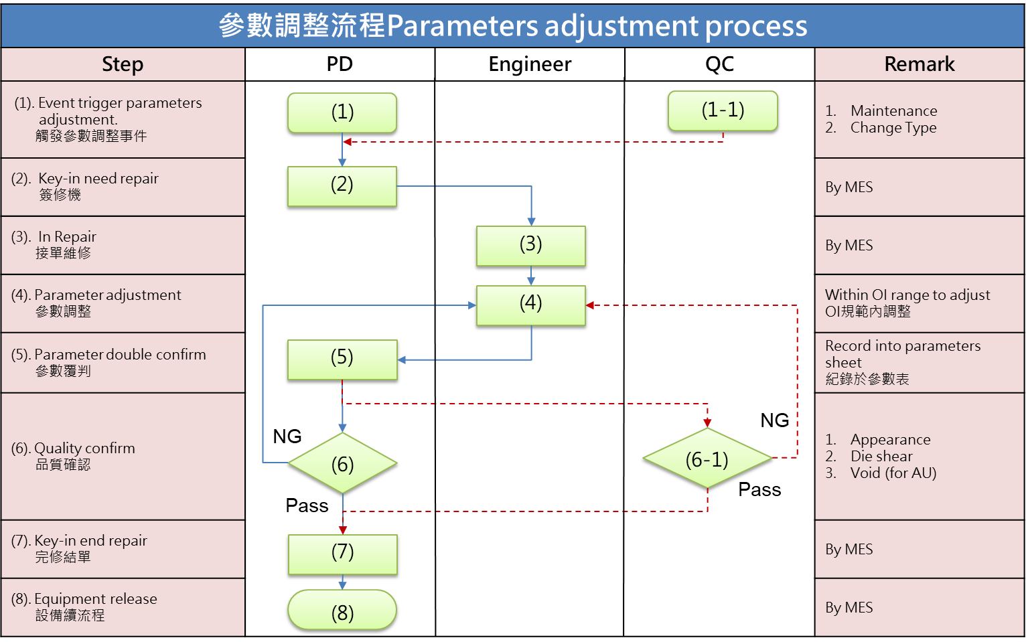

1. 異常處置　Abnormity Disposition

10.1 異常管制標準 Abnormal control standards

|  |  |  |  |  |  |
| --- | --- | --- | --- | --- | --- |
| 失效模式  Failure mode | OCAP文件  OCAP document | OCAP觸發機制  OCAP trigger mechanism | 低良率開單標準  Low yield standard | NCR開單標準 For Non-AU  NCR standard For Non-AU | NCR開單標準 For AU  NCR standard for AU |
| 晶推異常  Die shear failure | DB-OC007 | 1 time | 0收1退  0 accept / 1 reject | > 1% | > 0.5% |
| 晶粒位置問題  Die shift | DB-OC008 | 1 time | > 0.5% | > 1% | >0.8% |
| 帶晶 Die on collet | DB-OC017 | 30次/批 | > 0.5% | > 1% | >0.8% |
| 晶粒吸不起來  Pick up miss | DB-OC022 | 30次/批 | > 0.5% | > 1% | >0.8% |
| 吸嘴印Collet mark  (晶粒外觀) | DB-OC009 | 1 time | > 0.5% | > 1% | >0.8% |
| 空晶No Die | DB-OC016 | 30次/批 | > 0.5% | > 1% | >0.8% |
| 晶粒汙染  Die Pollution | DB-OC021 | 1 time | > 0.5% | > 1% | >0.8% |
| 腳架汙染  L.F. Pollution | DB-OC006 | 1 time | > 0.5% | >1% | >0.8% |
| 晶粒刮傷 (晶粒外觀)Die Scratched  and Incoming Material Issue | DB-OC009 | 1 time | > 0.5% | > 1% | >0.8% |
| 摔料  Material drop | DB-OC024 | NA | NA | 0收1退  0 accept / 1 reject | 0收1退  0 accept / 1 reject |
| 混料Material mixing | DB-OC018 | NA | NA | 0收1退  0 accept / 1 reject | 0收1退  0 accept / 1 reject |
| 晶片背面金屬鍍層脫落  Wafer Metal Peeling | DB-OC019 | NA | NA | 0收1退  0 accept / 1 reject | 0收1退  0 accept / 1 reject |
| Void過大Void Issue | DB-OC014 | 1 time | 0收1退  0 accept / 1 reject | > 1% | >0.8% |
| 腳架鍍銀層異常  L.F. Coating Issue | DB-OC023 | 1 time | NA | 0收1退  0 accept / 1 reject | 0收1退  0 accept / 1 reject |
| Q-Time超時  Queue time timeout | DB-OC004 | 1 time | 0收1退  0 accept / 1 reject | 晶推力低於OI規格  Die shear out of spec | 晶推力低於LCL規格  Die shear out of LCL |
| 腳架氧化  Leadframe Oxidized | DB-OC026 | 1 time | > 0.5% | >1% | >0.8% |

10.2 不良品圖示 Failure photos

| 不良項目  NG item | 圖例 Photos |
| --- | --- |
| 晶粒位置問題 Die shift |  |
| 帶晶 Die on collet |  |
| 晶粒吸不起來 Pick up miss |  |
| 吸嘴印Collet mark |  |
| 空晶No Die |  |
| 晶粒汙染 Die Pollution |  |
| 腳架汙染 L.F. Pollution |  |
| 晶粒刮傷 Die Scratched and Incoming Material Issue |  |
| 台車翻倒(內有半成品) Rock dropping |  |
| 晶片掉落(整片Wafer)Wafer dropping |  |
| 摔料 Leadframe dropping |  |
| 混料Mixture |  |
| 晶片背面金屬鍍層脫落 Wafer Metal Peeling |  |
| Void過大Void Issue |  |
| 腳架鍍銀層異常 L.F. Coating Issue |  |

1. 應用表格　Application Forms
   1. 小信號上片站外觀抽驗記錄表 DB appearance check sheet for small signal F-RD09M4
   2. Assembly Lot Line Traveler Card F-MF0836
   3. 小信號元件DIE BONDER檢查記錄表(DBD4200) DIE BONDER (DBD4200) for small signal product record sheet F-RD09L8
   4. 溫濕度記錄表 Temperature and Relative Humidity record sheet F-RD09F1
   5. 防潮氮氣櫃檢查記錄表 Dry cabinet record sheet F-PE0931
   6. DIE / WIRE BONDER吸嘴及銲針更換記錄表 Die / Wire Bonder Collet & Capillary change record sheet F-PE0945
   7. 新川機台參數點檢紀錄表 Shinkawa product record sheet F-PE09C7
   8. 吸嘴及軌道清潔確認紀錄表 Collet and track check sheet F-PE09D0
   9. 離子風扇點檢表 Ion fan check list F-PE09C0
   10. ESD靜電防護管制規範 ESD Electrostatic protection Standard W-PE0916
   11. AD832UR參數點檢表 AD832UR machine parameter check record sheet F-PE09H6
   12. DB-PA002 Shinkawa參數表 Shinkawa parameters sheet DB-PA002
   13. DB-PA003 JCMTOSOK參數表 JCMTOSOK parameters sheet DB-PA003
   14. DB-PA004 ASM AD832UR參數表 ASM AD832UR parameters sheet DB-PA004
   15. ASM一貫機AD832UR機台參數檢查記錄表FOR EAP ASM IN-LINE AD832UR machine parameter check list FOR EAP F-PE09J9